
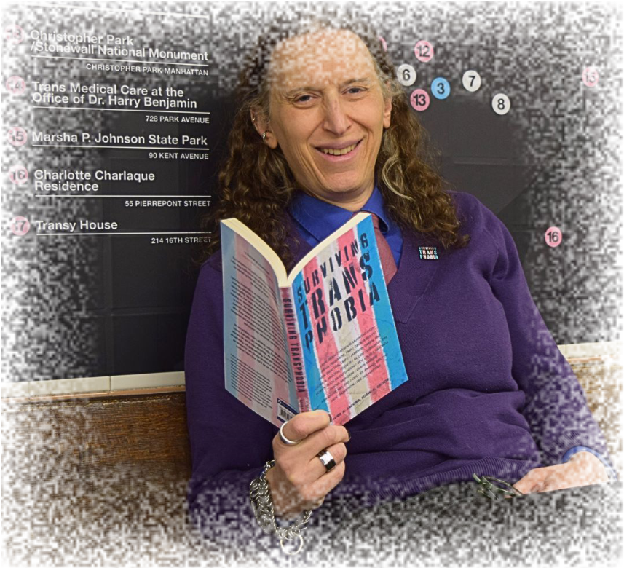
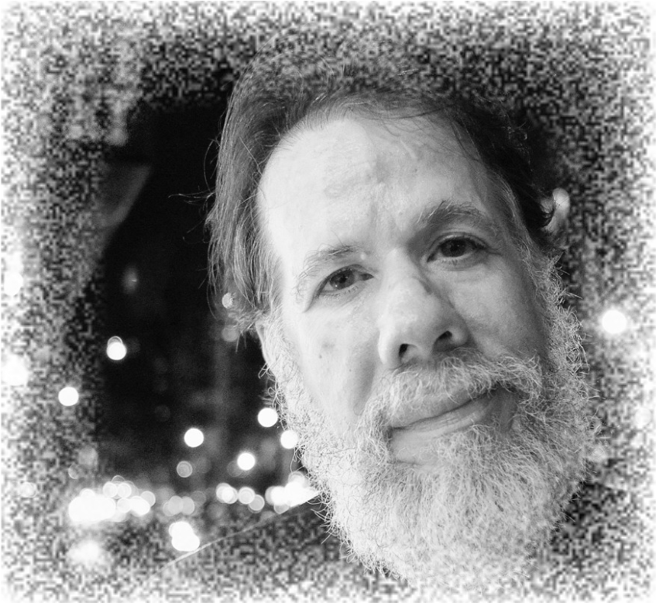
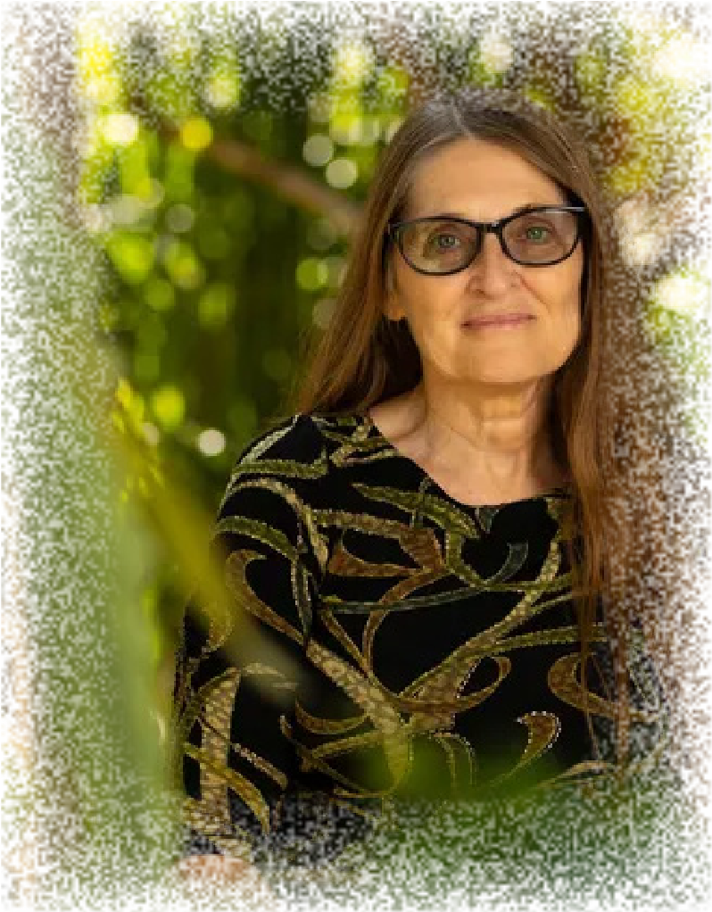
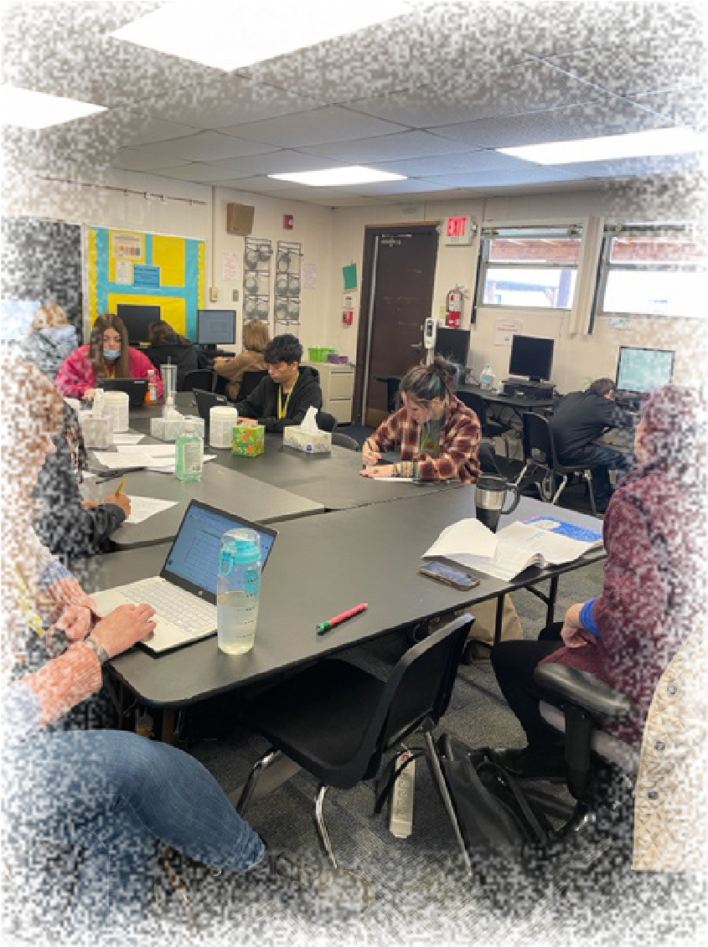
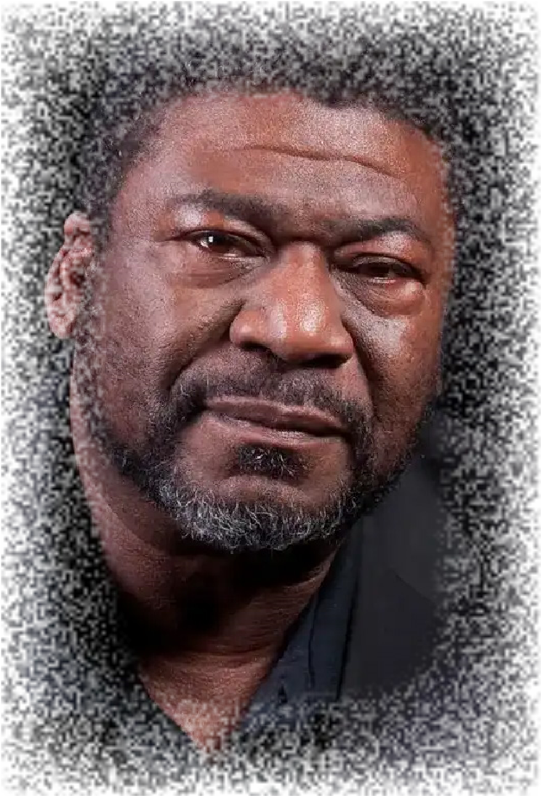
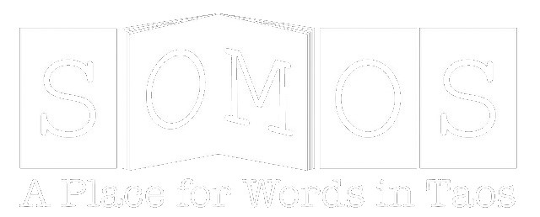
ANNUAL REPORT
2024

2024 SOMOS Board of Directors and Staff
Board of Directors:
Maria Teresa Garcia – President
Susan Mihalic – Vice President (as of August ’24)
Baksim Goddard- Treasurer
Olivia Romo-Secretary (until her resignation as secretary after the June ’24 meeting)
Rick Haltermann-Board Member at Large
Alan Macrae-Ex-Officio Board Member
Three Board members resigned over the summer of 2024: Tom Tasker, Amy Boaz and Estelle Laure
– due to their term ending and/or time constraints; as of November we added two new at-large
Board Members: Lisa Garza and Lupita Morgas
Staff
Jan Smith, Executive Director
Lauren Green, Administrative Assistant
Isobel O’Hare, Administrative Assistant
Danielle Freeman, Volunteer Bookshop Manager
And gratitude to our front desk volunteers and our behind-the-scene book dusters, sorters, and shelvers who keep our bookshop in operation!
Leslie Bishop, Miles Kimber, Michael Blevins, Sarah Stitt, Kathy Claunch, Terry Patton, Pat Smith, Susan McIntosh, Sandy Tonneson, Danielle Reyes, Barbara Jones, Emily Moore & Sky Roshay, Linda Fair, & Dami Roelse.
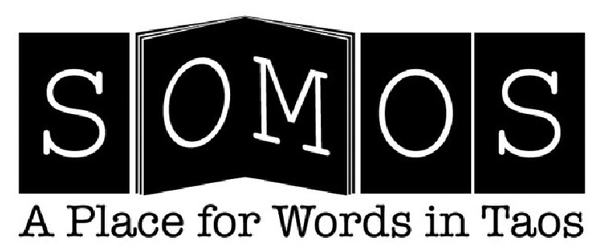
January 2025
Dear SOMOS members,
Thank you for your ongoing support of our organization and our flagship events: Poetry and Prose Months, Taos Poet Laureate, Heritage Reading Series, Writers Showcase, Annual Taos Writers Conference, Storytelling Festival and Young Writers Program. We continue to receive positive feedback from participants on these programs as well as Open Mic, Community Readings, Workshops, and the Annual Young Writers Conference. I encourage you to check our website regularly for the latest information on our programs and events.
Miguel Santistevan began his two-year tenure as Taos Poet Laureate in January 2024. For the 20242025 theme of “Poetry with Youth, ” Miguel is recruiting young people to submit poetry, artwork and photographs for a project called “Home: the Good, the Bad and the Ugly.” Upon completion, this work will be presented in a self-published zine.
In January 2024, Taos Main Street Executive Director Charles Whitson offered SOMOS an opportunity to participate in a “Façade Improvement” project with a matching grant of reimbursable funds up to $5000. Along with Charles, William Powell, the New Mexico Main Street Design & Preservation Program Specialist, assisted us with design plans. The Board pledged to raise funds and/or provide in-kind work to meet the grant’s match requirements. The priority was to upgrade the SOMOS Bookshop’s facade’s original stucco façade from 1950. To date, we have renovated the front exterior of our building with new stucco, paint and handicap accessible cement ramps. Additional work will include new signage, railroad tie replacement, and improved lighting that will meet dark sky objectives.
One of our fundraising events in 2024 was a raffle for a “Bag of Taos Treasures.” The ED and Board members contributed or secured donations from local businesses to fill a canvas SOMOS book bag. Donations included gift certificates for various businesses, hotel stays, punch cards to a local spa, a deluxe water bottle, a copy of Natalie Goldberg’s latest book and other items. We anticipated the bag’s value would be approximately $500, and the bag would go to one person. Thanks to the generosity of Taos and Santa Fe businesses and individual donors, the bag’s contents were valued at over $1000! Needless to say, the winner was thrilled. Given the success of the raffle, we plan to have a similar one this year with multiple winners.
In 2024, our staff expanded with the hiring of Lauren Green as part-time administrative assistant. Lauren is a multi-instrumentalist musician, artist and woodworker who has lived in Taos since 2014. Her presence has shifted some of the workload from our Executive Director Jan Smith to allow her more time for program development and grant writing. Along with Jan and Lauren, Isobel O’Hare continues to handle posting of our weekly newsletter and other social media needs. Board member Susan Mihalic is doing double duty as Young Writers Program Curator. Volunteer Extraordinaire Danielle Freeman manages our bookshop and oversees our hardworking volunteers with both a personal and professional touch. These people are the backbone of our operations.
On behalf of the Board of Directors, I want to acknowledge our membership, the businesses and private and government entities who provide the donations and funding that allow us to sustain our mission and role as “A Place for Words” in Taos. We are honored to be the literary heart of our community.
With thanks,
Maria Teresa Garcia
President, SOMOS Board of Directors

SOMOS Taos Poet Laureate Report 2024
Miguel Santistevan became the 4th Taos Poet Laureate (TPL) on January 1st, 2024. The two-year term as TPL is driven by a youth-project called “Querencia en Poesia” or ‘Sense of Home’ in Poetry. The project proposed was to conduct youth poetry workshops to inspire the youth to write their poetry and publish them in a ‘Zine. Along the way, the TPL will also look for opportunities for the youth to recite their poetry in public venues.
After an initial meeting with the Executive Director of Somos, Jan Smith, in mid-January, Miguel started organizing potential presentation dates along with creating the presentation. A PowerPoint presentation was created to introduce Miguel as the TPL that included the life-defining moments that led to poetry as a means of expression and concluded with a summary of the project and how students could contribute. The presentation then moved into a writers’ workshop in which another PowerPoint presentation of Miguel’s digital photography from around New Mexico that was intended to show the beauty of our homeland with occasional images that showed challenges New Mexico faces in terms of pollution, water shortage, and climate change. The juxtaposed images were intended to invoke themes around the subtitle of the project “The good, the bad, and the ugly.” The intention was to get students to write about what they love about home and what they are also concerned about with regard to their sense of place and home.
Presentations and writers’ workshops were held at Taos Academy on February 22nd for 9th graders; for the Taos Education & Career Center students at UNM-Taos on February 29th for High School students; for Peñasco Middle School students on March 7th; for TISA Middle School students on April 4th; and for Anansi Middle School students on May 2nd. From these writers’ workshops the TPL was able to gather approximately 54 poems as well as artwork to be used in the ‘Zine.
Miguel also organized a writers’ workshop held at the Taos Public Library the afternoon of May 2nd. Recruitment for this workshop happened at the writers’ workshops mentioned above in addition to emails to various English and Language Arts teachers in Taos and Vista Grande High Schools in addition to the Taos News. To incentivize participation in this workshop and for participation in general, a fundraiser was held to obtain six $25 gift cards which were given out at our Library writers’ workshop and Paseo Project reading (see below). In addition to writers’ workshops for youth, the TPL was able to represent this position in several gatherings and presentations. Miguel was introduced as the TPL in a keynote to the Peñasco Middle/High School Parent Night on February 7th in which some of the youth poems were showcased. The next Friday, February 9th, Miguel was introduced as TPL to students from several schools in northern New Mexico at a Youth Legislative event sponsored by River Source. Poetry was recited to the vising Rocky Mountain School for Expeditionary Learning in early March for their annual visit to Sol Feliz Farm, Miguel’s agriculture education venue. Miguel presented a keynote speech with several poems to the Los Jardineros Garden Club at their annual meeting on May 9th at the Taos Country Club. A highlight of the Spring was to hear poetry from Santa Fe Poet Laureate Tommy Archuleta on May 18th at SOMOS with TPL Miguel Santistevan providing the opening poems.
Miguel was invited to recite poetry to a Social Justice group from Denver at the Casa
Taos retreat center on June 9th. He recited poetry in his keynote to students of the national
Rooted in Community conference at the University of New Mexico Sub Ballroom on July 18th.
Miguel was invited as TPL to recite Lorca poetry for Karen Thibodeau’s “The Butterfly’s Magic Spell” at the Wildflower Playhouse on July 19th, 20th, and 21st. Miguel was introduced as TPL, read a Land Acknowledgment, and served on a panel for the film screening of “Indigenize the Plate” at the Wildflower Playhouse on September 10th. On September 17th, Miguel recited poetry at Northern New Mexico College in a celebration for Hispanic Heritage Month. Miguel has been participating in the Paseo Project in Taos for several years with his “Acequia Apocalypse” multi-media installation. Given his position as TPL, Miguel was offered the stage of the Taos Community Auditorium for a youth poetry reading immediately following the showing of his installation. Students from all the writers’ workshops were recruited to read their poems for this event. The imagery from the writers’ workshops was shown on the big screen while three students read their poems. The students also read the poems of other students who were not able to attend the event but who were comfortable with other students (or the TPL) reading their poems on stage. We had a student from UNM-Taos, Anansi, and Taos Academy participate in this event. A blog entry from this day can be read in the archives found at: https://escuelasolfeliz.com/blog/
The year ended with a meeting at the beginning of December with Jan Smith at SOMOS to prepare for the 2nd year of Miguel serving as TPL. The coming year will be as full of readings and representations as it was in 2024. In particular, the ‘Zine will be finalized and showcased in March with a youth reading at SOMOS or the Library. Once this is done, more writers’ workshops will be planned and hopefully more youth voices can be showcased at Paseo 2025. In reflection, the position of TPL hopefully inspired more poetry in the minds and hearts of youth. As one young lady wrote in one of her poems “…I am crying on the inside, trying to find my voice….” Following are some quotes from some students who provided reflection from the TPL’s writers’ workshops:
“Miguel does poetry. He is a passionate speaker.”
“He opened a new perspective about poetry. His stories were interesting to hear about.”
“Every person was grateful to hear him and for the adventure he showed us.”
“I think his way of thinking and speaking are enjoyable to listen to”
"His statement about how words shape our reality was fascinating to think about, as I had never thought about it like that before.”
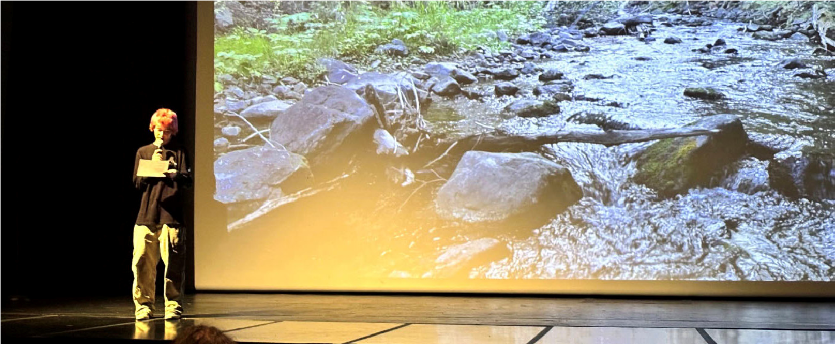
Lee, 8th grade student at Anansi reading his poem accompanied by a photograph Submitted by Miguel Santistevan

SOMOS 2024 12th Annual April Poetry Month
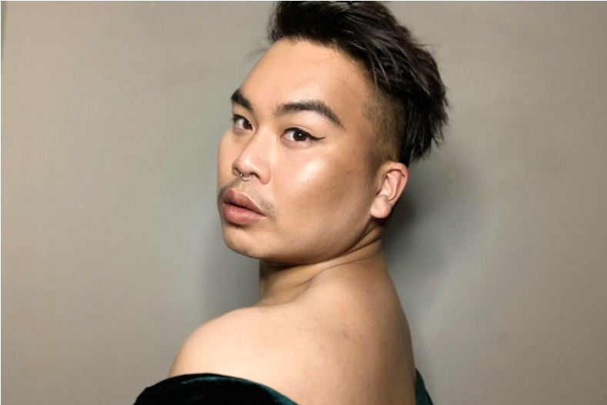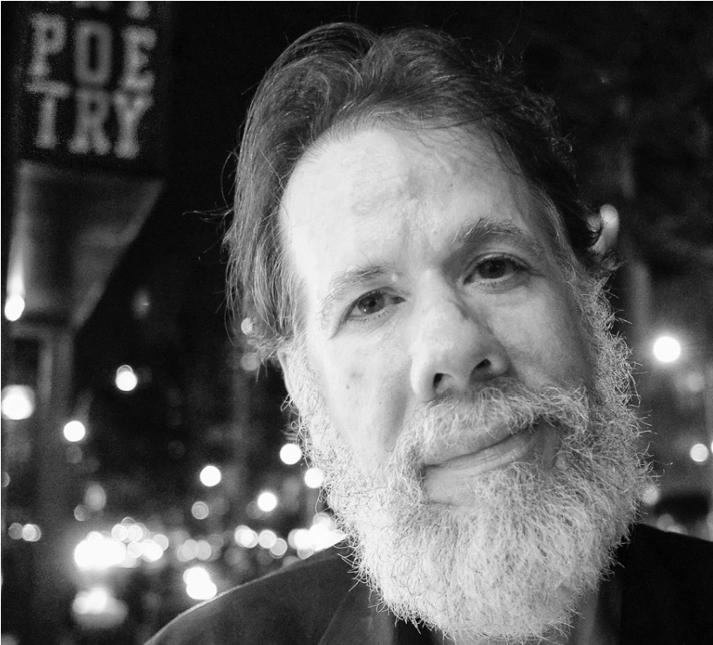

Featured Poet, Martín Espada
The featured poet for the 2024 April Poetry Month was award-winning Martin Espada who has published more than twenty books as a poet, editor, essayist, and translator. His newest book, Floaters, won the 2021 National Book Award. Although he was scheduled to travel to Taos for his reading and three hour workshop, “My Last Name,” was presented via Zoom online. He read to an large and appreciative audience on Friday, 4/12/24, and taught his workshop the following morning, 4/13/24.
During the month there were thirteen poets who read as well as the final film project of Taos Poet Laureate, Joshua Concha, “Taos Poetry in Motion” at the Harwood Museum on 4/17/24 (rescheduled from a snow date in December, 2023. The annual Young Writers Program on 4/6/24 featured a group of student participants (Rozzlyn Sanchez, Solymar Espinoza, and others, accompanied by musician, Jimena Ballesteros).
Other poets included Leslie Ullman, Dale Kushner, El Bosque poets: Judith Buffaloe, Robert Templeton, Cedar Koons, and Tim Raphael, Tina Carlson, Katherine Seluja, Veronica Golos, Will Barnes and Heidi Sanborn.
Over one hundred fifty people attended Poetry month.
Submitted by Jan Smith

8th Annual Taos Writers Conference, 7/7-7/9/2024
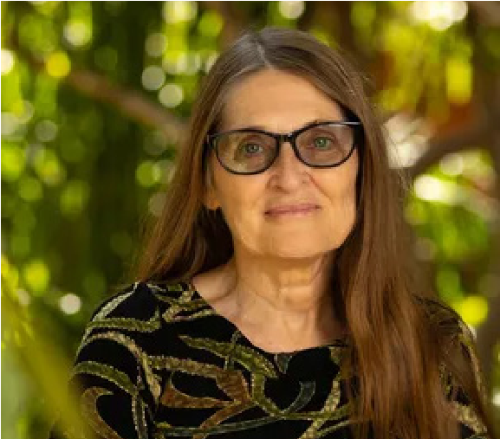

Allison Hedgecoke, keynote speaker for TWC
The annual Taos Writers Conference opened on Friday morning, 7/9/24 at 9am with registration for the day’s intensive workshops, from 10am – 4pm with six choices of instructors and content: Tommy Archuleta (poetry), Valerie Martinez (poetry), Susan Mihalic (prose), Sean Murphy (prose),Connie Josefs (memoir) and Leticia Gomez (publishing). At 5:30pm the keynote speaker, Allison Hedgecoke, took the stage and read from her fulllength poem, Look At This Blue.
On Saturday from 9am to 12 there was a choice of five workshops led by Hedgecoke, Jamie Figueroa, Catherine Strisik/Veronica Golos, Jean—Marie Saporito, and Lauren Bjorkman. During a lunch break Susan Mihalic gave a presentation on collaborating with Agents and Editors based upon her experience writing and publishing her debut novel, Dark Horses. The afternoon workshops included sessions by Lauren Camp, Minrose Gwin, Sawnie Morris, & Sharon Oard Warner followed by faculty readings and book sales. On Sunday morning the conference concluded with five more workshops from 9am -12 with Sawnie Morris, Julia Goldberg, Susannah Simpson, Allegra Huston & Mark Lipman.
Since 2020, the conference has offered at least three live workshops held at SOMOS (and nearby venues) and two online workshops. This has afforded both students and faculty to save the expense of time and travel and has proven to be successful.
The 2025 conference will feature poet, prose writer, and memoirist, Nick Flynn on 7/25—7/27/25.
Submitted by Jan Smith

26th Annual Storytelling Festival, October 11th—12th, 2024
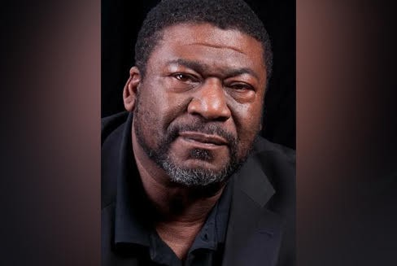

Dr. Raymond Christian, 2024 Headliner Storyteller
As has been tradition SOMOS scheduled four unique events during Storytelling
Festival weekend: a Community Storytelling event at the Talpa Community Center;
“The Art of Storytelling” workshop led by Ray Christian at SOMOS; a free Story Swap on Saturday afternoon at the Hacienda Martinez, and the finale at the Taos Center for the Arts later that evening, featuring emcee and teller Cisco Guevara, Regina Ress, and Dr. Raymond Christian.
The community event on Friday evening, 10/11, was again a “sold-out” crowd with over 100 people in the audience. SOMOS board member, poet, and acequia activist, Olivia Romo, curated the evening with a talented selection of local and regional tellers and musicians. They included Paulette Atencio, Lara Mazanares, Maria Dolores Gonzales,
Roberto Lavadie, Joseluis Ortiz, and Alexi Fernandez, a Taos High School student in the Spanish language program. Dinner was included with the optional $5 donation and consisted of posole, chili, cornbread, tortillas, beverages, and desserts. A tickets for a free used book at SOMOS was offered to each attendee. Spirits were high and the stories and music soared!
Saturday morning Christian led a poignant deep dive into the art of storytelling with eighteen students. Christian regaled us with some of his more successful as well as failed stories to draw a sharp contrast in strategies for memorized performance stories. Twists, turns, gestures, voice modulation and more were demonstrated in the two-hour workshop with the opportunity for participants to practice their own stories.
Later that afternoon a free Story Swap was held at Hacienda Martinez, facilitated by Storytellers of New Mexico member, Regina Ress. Approximately twenty people attended and shared their tales.
The grand finale began at 7pm at the Taos Center for the Arts with three featured tellers, Cisco Guevara, Regina Ress and Dr. Ray Christian. One hundred and ten audience members attended.

2024 SOMOS Prose Month
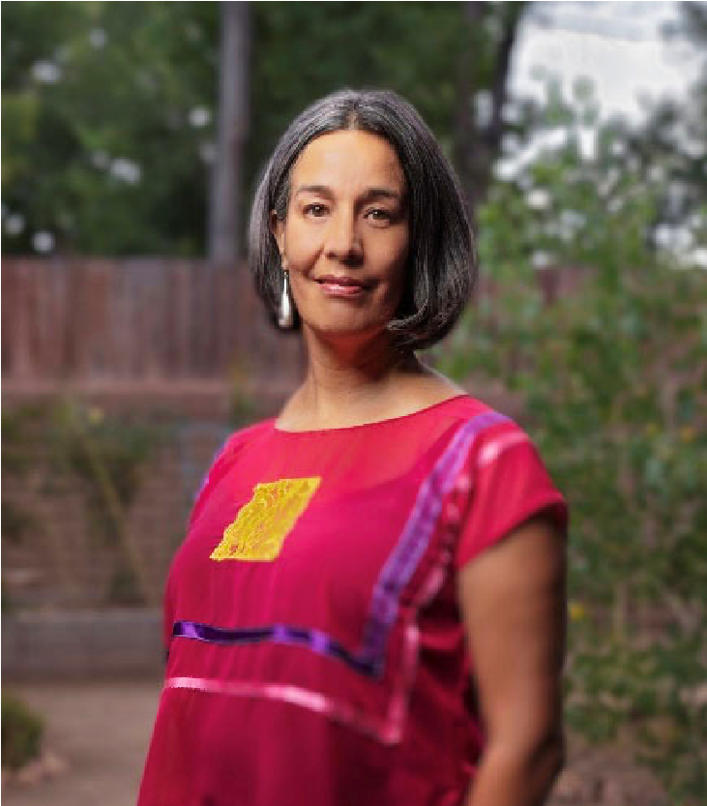
Our 2024 8th Annual Prose Month series held November 1st through November 23rd highlighted eleven author readings, two sessions of NaNoWriMo led by Johanna DeBiase, and two workshops: Michael Blevins -- Tips of Self-Publishing; Jan Smith – Craft & Critique. The series began with a reading by prolific Santa Fean writer and philanthropist, Sallie Bingham, who read from her latest book, Taken by the Shawnee, a fictional adventure story based on the life of Margaret Erskine, her many times great grandmother. Alongside her was Rebecca Reynolds who read and answered questions from her nonfiction book, Thresholds of Change: The Way Through Transformational Times. Reynolds is a consultant offering both profit and nonprofit organizations pioneering new meth-
_{Michelle Otero} ods and models of change in diverse and far-reaching projects.

On November 10th author and poet Emily Lutken read
from her memoir about her father’s service as a jungle warrior during WWII in Burma, A Thousand Places Left Behind. Lutken shared a slide show presentation including originals photographs, maps, and memorabilia from Peter Lutken’s experiences from 1941—45 as well as charitable works for the Kachins (US ally in WWII) long after until his death in 2014. On Wednesday November 13th a quartet of writers, all contributors to “Deep Wild: Writing from the Backcountry” read their words from the wild including authors Rick Kempa (founding editor), Ed Brown, Tim Raphael, and John Nizalowski.
They were followed two evenings later on 11/15 by local writer, photographer, and environmentalist, Jim O’Donnell, who did a book launch with his newest, Fountain Creek. Raised in Pueblo, CO, O’Donnell spent years tracing, observing, and recording wildlife and water effects in Fountain Creek that runs from Pueblo to Woodland Park.
It seems this year’s Prose month’s theme was “living in the wild” as the next authors,
Christina Green and Erika Howsare read from their books, Moonlight Elk: One Woman’s Hunt for Food and Freedom and The Age of Deer, respectively, on 11/16. Two women hunters and admirers of wild creatures shared their experiences, learnings, and transformations.
Michelle Otero, former ABQ Poet Laureate, read from her awarded memoir, Vessels: A Memoir of Borders, a chronicle of calling upon the wisdom of her many ancestors to heal from trauma, loss, and the shadows of war, resulting in lighting the way with the promise of wholeness and healing.
Deborah Jackson Taffa, the Director of the MFA program at IAIA, was scheduled to read from her memoir, Whiskey Tender, with Otero. However, her book was longlisted for the National Book Award, and she had to travel to the East Coast for the announcement of the winners. SOMOS hopes to have Taffa read in the future.
Submitted by Jan Smith

2024 Community Readings & Workshops
Writers Showcase: Martín Espada, Laura Jacobs, Allison Hedgecoke, Dr. Raymond Christian (210)
Taos Writers Conference twenty workshops and keynote reading (74)
Hispanic Heritage Month: Anita Rodriguez (32)
Storytelling Festival: Community event, workshop, storyswap and main event (250) LGTBQ+ Month Laura Jacobs (36)
Open Mic, 3rd Thursday/month hosted by Mike Murphy (average 8—20 at each) (120)
Community Readings: 32, average of 10—25 per event (800)
Rental Spaces UU Book Club & Noetic Science Group, once/month each
DEI training w/NPACT 16 hours with Megan White and Margaret Romero
Transgender training 4 hours with Transgender Resource Center (25)
Literary Memorial at the TCA in honor of John Nichols (265)
Craft & Critique workshops, once/month for eight months (40)
Self-publishing workshop (6)
Young Writers Night (42)
Collaborative events Invent Event at Enos Garcia gym, monthly NPACT meetings (Nonprofit
Arts & Culture Together)
Total served (not including Young Writers Program or patrons of the bookshop): 1900
Fundraisers: Raffle drawing in August, and Yard Sale in October

Young Writers Program Spring Semester 2024
Young Writers Salon and Showcase:
A core group of students have been working with me since 2019, and most of them were graduating this year. Those students were encouraged to develop three poems about home, youth, growing up, and to explore those themes. None of them plan to write for a living, so all were acutely aware of the privilege and gift of writing in a group, every week, and expanding. All plan to use it as a tool as they move forward. We met on Wednesdays from 5-6, but over time it slid into 6:30, then eventually 7:30. I also met with each student individually and mentored them to get their poetry prepared.
Students were interviewed by a number of local organizations, including the TCA and the Rotary Club, where they read poetry and talked about their experiences with SOMOS. One student, Rozzlyn Sanchez, was also showcased by The Taos News as a “woman to watch”, while another, Solymar Espinoza, served as emcee at Night of a Thousand Stars, where she also read the poetry we worked on. The Young Writers showcase was held on April 6th, at SOMOS, and was very well attended and featured music from Jimena Ballesteros. We also had an addition from TISA, a sixth grader who had been working with peer mentors through the program. It was and emotional evening, and the end of an era!
The Next Generation:
A new group was formed, Writers Lunch Club, which was held at Taos Academy Mondays at noon, and which consisted of between five and ten up-and-coming middle school writers. All of them were working on longer form, so I chose prompts focusing on development (and lots of fun). It was well attended, and my hope was to invite a new generation of writers into the program.
Mentoring Program:
It’s been wildly difficult to arrange mentors since Covid. Students are less interested in working with mentors who are elderly and parents more skeptical of allowing it, especially in person, so we decided to go another direction. With my background in education, I am aware of how powerful peer mentoring can be, so I made alliances with chapters of the National Honor Society. They are required to do community service hours, so some chose to work with students to help them develop as writers. TISA has an after school program, which felt like a perfect fit, and NHS members went weekly from February through the end of the school year, with Sally Greywolf as the liaison. I would call that a great success. I know TISA appreciates the enrichment for the children, and it’s a great way for NHS to fulfill its obligations. I received very positive feedback on all counts. It’s my opinion that the mentoring program will need to move further in this direction and adapt in order to succeed long-term.
School visits:
I really wanted to expand this part of the program. I believe we can truly provide a service in this way. Teachers have a tight curriculum and face many pressures to teach to tests, raise test scores and proficiency levels, and sometimes creativity and fun get lost in the mix. The heart, the gut, the art is secondary to these other concerns. Therefore I took the budget I was given from a grant by the Rotary Club, and used it to send Poet Laureate Miguel Santistevan and critically-acclaimed author Susan Mihalic into the community. Also, being a teacher myself, I know how overwhelming the internet is, and how much false information is out there, so I asked Pamela Pereyra, consultant on Media Literacy to go into Taos High School and teach students about Media Literacy, a skill they can take with them into the future. This felt like a perfect use of funds as it provided fun, education, and exploration on all counts.
Last, Susan Mihalic took on a Young Writers Workshop, which was held at TISA during finals week. This was four hours, with rotating groups of students, to give them respite from the stress of testing. She worked with 5-8 grade and this yielded positive results.
While I don’t have exact numbers, I estimate more than 300 youth were served through the program in the spring.
Here are some blurbs from our guest artists:
Susan Mihalic, author of Dark Horses (Scout Press, 2021), worked with 45 high school students at Taos Academy for two sessions of 1.5 hours each and a total of 45 students in grades 5-8; and she worked at TISA for four sessions of 40 minutes each. During this time, she had students free-write in response to prompts designed to promote descriptive thinking and writing. All prompts encouraged students to write from their own personal experiences. Writing was shared aloud without critique to bolster students' confidence in expressing themselves.
Pamela Pereyra's students were receptive to the information and had fun creating some conspiracy theories, showing that they understood the concepts. One student commented, "This information is so important" about the deconstruction activity. The creation of student conspiracies were insightful to hear them plan and write ideas that were far fetched and somewhat believable. They had fun learning. The English class has had a long-term
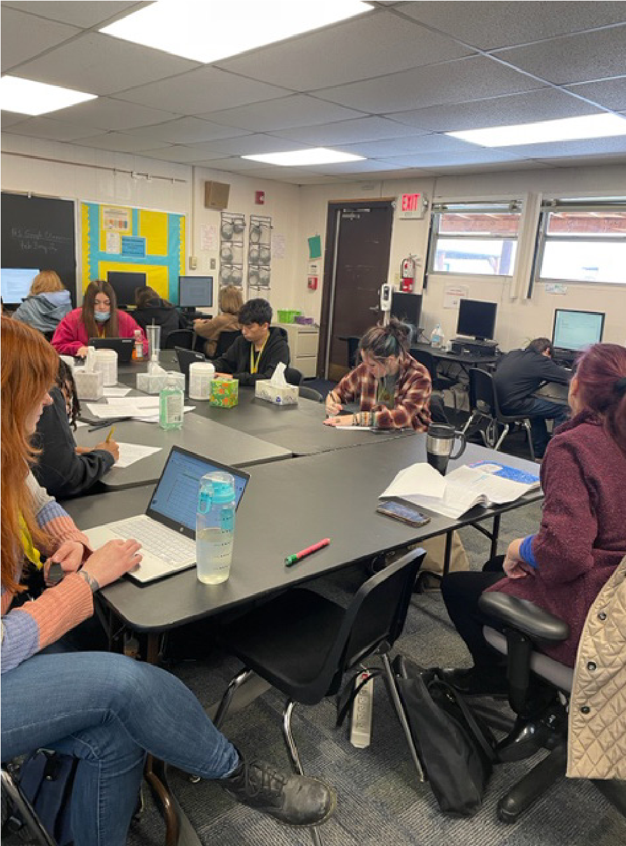
sub, and our project was different and academic at the same time.
Miguel Santistevan was not able to provide a blurb, however he did a two- hour workshop at TISA, as well as four hours at Taos Academy, and did workshops focusing on the local landscape and the connection between the land and our spirits. He also talked about querida. This was a generative workshop, and students wrote poetry about water and mountains. All students had at least one finished poem at the end of the session and he collected many of them for his poet laureate project, to use in the “zine” he’s creating.
This concludes my tenure in this position. I hope I have met my goals of expanding and adapting the SOMOS Young Writers Program into the community. Susan Mihalic will be taking over as of August.
Respectfully submitted by Estelle Laure, Vice President of SOMOS Board, and Curator of the Young Writers Program

Young Writers Program Fall Semester 2024
The 2024 fall semester was a time of transition for the Young Writers Program as longtime curator Estelle Laure retired from the position and SOMOS board member Susan Mihalic assumed the role of curator. Susan was one of the writers invited by Estelle into classrooms at Taos Academy and Taos Integrated School of the Arts (TISA) in the 2024 spring semester. As a visiting writer, Susan led students in free-writing exercises.
The 2024 fall program involved presenting weekly workshops at TISA, where Susan worked with up to nine students of varying heritage (one Native American student, three Hispano students, and five Anglo students). Eight of the students are in sixth grade; one student is in eighth grade. All TISA students are currently working on stories on their own or in collaborative pairs; most are writing fan fiction, but in the first session of 2025, held on January 7, at least one student is now working on original material.
During the fall semester, Susan reached out to both Taos Academy and Taos High School to gauge student interest in participating in the Young Writers Program. While visiting English classes with THS principal Emy Martinez-DeHerrera, she talked about the Young Writers Program and invited interested students, their grown-ups, teachers, and administrators to attend a Young Writers Night at the SOMOS office for a more in-depth presentation. Although the evening was well attended, the planned writing session at SOMOS the following day had no participants. The conclusion drawn from this is that the workshops and writing sessions are more successful when they are brought to the students at school, which is the plan going forward. The schedule is to be determined. In addition, Susan will set up individual mentorships for students who are interested; so far one THS student has expressed interest.
In 2024, the Young Writers Program was fortunate to receive a generous donation from the Taos Lions Club, which will be used to bring visiting writers into both THS and Taos Academy this spring; TISA students, at age 11 (with one 13-year-old), are a bit young, and their thinking is a bit disorganized, to benefit from the visiting writer component of the program. On January 2, 2025, Susan attended a meeting of the Lions Club to offer our organization’s thanks to them for their support; she spoke about SOMOS in general and the Young Writers Program in particular.
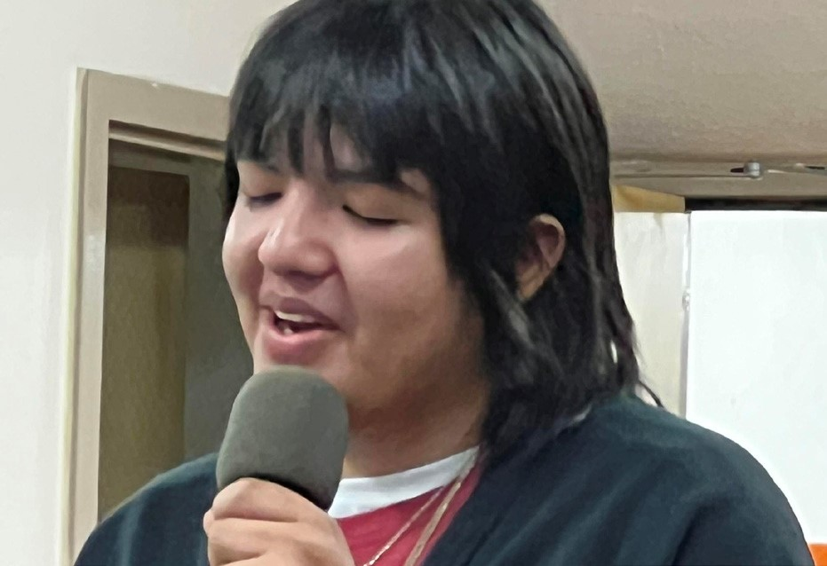
Young Writer reading their story in Spanish, October, 2024
Submitted by Susan Mihalic - Curator

2024 SOMOS Bookshop Report
Generally speaking, it was a good year for the Bookshop. Our volunteers were steady, the donations aplenty, the day-to-day sales totals were erratic, several the most dismal ever and some spectacular. We were seriously impacted by the street construction making access to the shop tricky, especially for the tourist months! Our financial contribution to the organization was $25,000 for 2024.
As far as the “special” sales, I have experimented with $1 sales and half-price sales; only $1 sales are popular. Subsections or unique collections are featured on table tops and in the Booknotes, although usually at regular prices.
When we have an overabundance of books, there are very few outlets for them so some very nice books end up in our Free Books. We still can contribute to the Adult Detention Center and the Shelter. The Free Books had to be moved to the back portal during the lengthy replastering project which seriously slowed their being taken.
Lauren, Jan’s assistant, has been posting book specials online and sprucing up the Bookshop section of the Website. This has been helpful for getting the word out. This was a goal last year.
We continue to offer Book Searches and Gift Certificates.
Some larger section signs are being considered i.e. The Arts, Literature, etc. so that customers can find their area of interest more easily. Help is needed for this to happen.
This past winter we again participated (by invitation) in TaosFolk which garnered $117. This is $53 less than last year, reflecting this slow holiday season.
As you all probably know, I am coming up on birthday #85. The years are catching up with me and I am slowing down. I’m still in the game, but with less mental energy and physical strength. So be on the lookout for my replacement.
Thanks to Jan Smith and the SOMOS Board for their continued support of the Bookshop and me!
Danielle Freeman
SOMOS Bookshop Mgr.
1/8/25
2024
SOMOS Financial Reports

We, at SOMOS, feel extraordinarily grateful to our sponsors, donors, and members for their continual generous and trusting support of our organization in fulfilling our mission statement.
Our FY24 budget that ended on December 31 reports that we have a net income of $29,645. The result is based on grant income that exceeded our expectation for a third year. The $15K budgeted expenditure on property maintenance and improvement was spent on a new boiler, stucco of the exterior walls of the building and new cement walkways.
The board has approved $8,600 in the 2025 budget for the continuous effort of capital investment of our property. SOMOS is in receipt of a small matching grant funded by New Mexico Resilience Alliance for the purpose of façade improvement as we are situated in the historic district on Civic Plaza Drive. Our ideas and efforts will be focused on new signage, light fixtures and painting.
While the board is excited by these new projects and the fiscal results for 2024, challenges remain in 2025. Our Executive Director and grant writer will be searching for new grant donors to replace the grant income of a generous donor for the last three years. In addition: the loss of income of the rental unit that is currently vacant, and the renovation of the space will be in excess of $5K.
Again, we cannot end our financial report without extending enormous thanks to our volunteers of our superior second-hand bookstore.
The Board of Directors at SOMOS thanks everyone in the community for your support, consideration, and participation.
Submitted by Baksim Goddard, Board Treasurer
SOMOS OPERATIONAL BUDGET FY 2024
REVENUE
PROGRAM INCOME
Membership Dues Income | $9,000
Gate Income | $2,500
Workshop Income | $12,000
Rental Income/Office | $250
Bones Admin Fee | $560
TWC | $17,500
SUB TOTAL | $41,810
FUNDRAISING INCOME
Parking Income | $120
Grants | $65,000
McCune Discretionary Fund for DEI training | $2,500
Donations | $4,000
Sponship | $3,500
Appeal Letter | $10,000
Fundraising Event | $4,000
Book Sales | $25,000
SUB TOTAL | $114,120
RENTAL PROPERTY INCOME
Rental Unit Income | $10,750
SUB TOTAL | $10,750
OTHER INCOME
Dividends | $3,000
Interest Income | $15
SUB TOTAL | $3,015
TOTAL INCOME | $169,695
EXPENSES

EXPENSES
PROGRAM EXPENSES
Curator Fees |  | $5,000
Honorarium |  | $10,000
Workshop Instructors |  | $3,000
TWC Instructors |  | $10,000
Storytelling Presenters |  | $4,000
Supplies |  | $100
Facility Rental Expenses |  | $500
Travel and Lodging Expenses |  | $3,000
Refreshments |  | $500
Advertising |  | $10,000
Video |  | $400
Book Sales to Authors |  | $1,400
Volunteer Appreciation |  | $350
SUB TOTAL |  | $48,250
ADMIN EXPENSES
Administrative Services |  | $5,200
Accounting |  | $3,200
Dues |  | $500
Printing and Reproduction |  | $100
Gas/Electric |  | $3,500
Trash Collection |  | $300
Water |  | $1,400
Telephone |  | $1,500
Office Repairs |  | $1,500
Office Supplies |  | $5,000
Postage/Delivery |  | $500
Liability Insurance |  | $3,200
Business Meals |  | $700
Bank and Credit Card Fees |  | $1,000
Paypal Fees |  | $800
Investment Fees |  | $750
Education |  | $3,000
DEI Consultation and Training |  | $2,500
990 T-Tax |  | $600
SUB TOTAL |  | $35,250
PAYROLL EXPENSES
Excutive Director Wages |  | $53,000
Employee Benefits (for ED) |  | $3,000
Payroll Taxes |  | $4,195
Administrative Assistant |  | $9,000
SUB TOTAL |  | $69,195
Misc EXPENSES
Fundraising Expenses (Printing & Design) |  | $250
Leasehold Improvement Budegeted (Building Repair) |  | $14,500
Rental Repair Expenses |  | $2,500
SUB TOTAL |  | $17,000
TOTAL EXPENSES |  | $169,695

SOMOS
thanks all our donors and
funders for supporting our
literary programming and bookshop during 2023. Funding organizations
include: Taos Community Foundation,
New Mexico Humanities Council, McCune
Foundation, Nusenda Foundation,
J3 Advised Fund, TCLT, New Mexico
Tourism Department,
New Mexico Arts, Virginia Wellington Cabot Foundation, Smith’s Inspiring Donations, Libro.FM audiobooks.
A
P
P
L
A
U
S
E

A
P
P
L
A
U
S
E

A
P
P
L
A
U
S
E

A
P
P
L
A
U
S
E

A
P
P
L
A
U
S
E

A
P
P
L
A
U
S
E

A
P
P
L
A
U
S
E

A
P
P
L
A
U
S
E

A
P
P
L
A
U
S
E
We are also extremely grateful for the loyal support of our members, event
attendees, and bookshop patrons.
We could not thrive without your generosity!
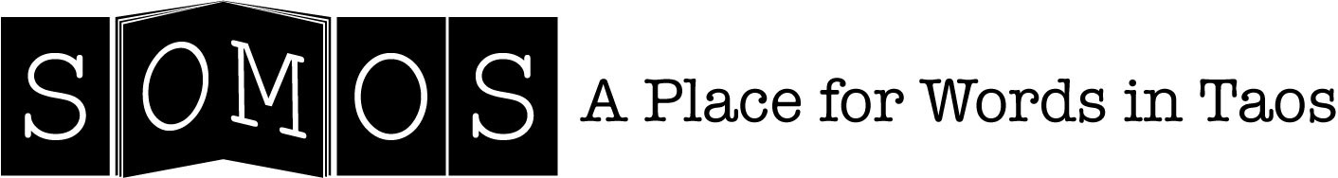
108 Civic Plaza Drive Taos, New Mexico 87571 somos@somostaos.org somostaos.org

